Project-2

DEPLOY A STATIC WEBSITE ON AWS

**Creating a Bucket:**

**->**Open the Amazon S3 console by logging into the AWS Management Console .

-> Clickon **CreateBucket**.

->Choose **Bucket Name –**Bucket Name Should be Unique.

-> **AWS Region –**  Choose a region close to you or the region where you want to create the bucket (Example — Mumbai).

-> **Object Ownership –**Enable for making Public, Otherwise disable

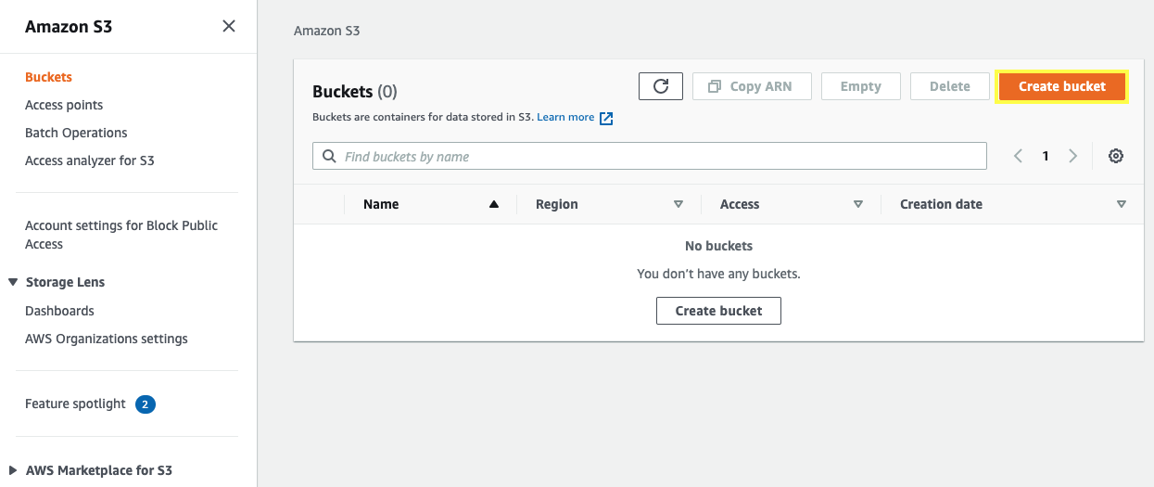

**Block Public Access settings for the bucket:**

->Uncheck (Block all public access) for the public, otherwise set default. If you uncheck (Block all public keys.

->Now, click on**Create Bucket**

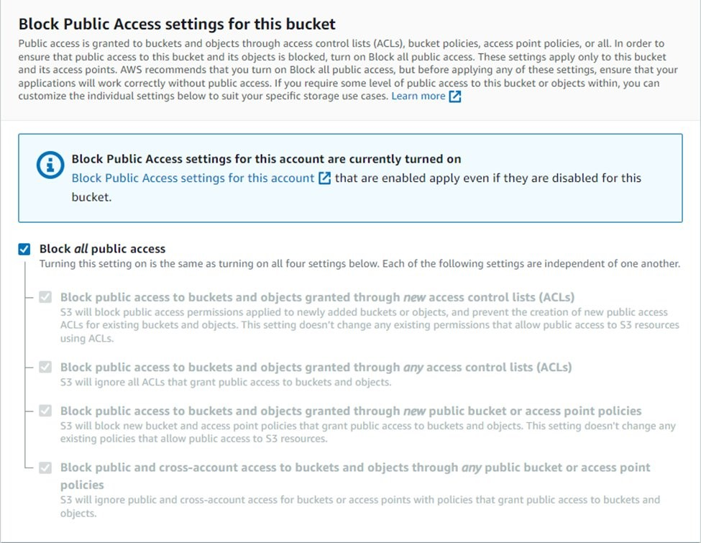

**upload code files:**

**->Select Bucket** and Click your**Bucket Name**.

->Now, click on upload (then click add File/folder) and select your **HTML code**file from your PC/Laptop.    

->After uploading, click on**Close**.

**->**Once the Files are uploaded successfully, click on **Permissions**and now follow this Process .

**1. Block public access:**

* + Click on **Edit,**under**Bucket Policy**.
  + **Uncheck Block** all public access.
  + **Save changes** then type “**confirm”**.

**2. Object Ownership:**

* + Click on **Edit**.
  + Click on **ACLs Enabled.**
  + **Check**I acknowledge ….. restored.
  + Choose**Save Changes.**

Make objects public:

->Now, Click on **Objects**.

->Select your **All Objects**.

->Now, Click on **Actions**.

->Select**Make Public Using ACL**.

->Now, Click on **Make Public** and **Close**.

**Copy your Object URL:**

->Now, click on your **HTML File** Object Name.

->Copy the **Object URL**.

**Check out your Website:**

->Directly Paste this URL into the Other Tab or your other System.

->You **Successfully Hosted** Your**Website by AWS S3.**

